The Table with the Input and Simulation results (Big table)
For this table we need a flexibility regarding the number of columns (number of parameters we display) and the order of the parameters. We also need a flexibility which parameters we display in this table. For example having a simulation series with the Nutsche as filter type we need different default parameters in the table than the default parameters of for example rotary filters.

But all filter types have the same equations (see all equations below)

Default Parameters for the table when selecting Nutsche Filter as Filter type

Nr. | SimSeries | Sim | Suspension | Filter medium | Machine Name | Filter Area/m2 | Δp  bar | Msus  kg | Vsusl | hc  mm | Tf  s

Mf  kg | Mcake  kg | Ms  kg | Qmsus  Kg/h | Qsus  l/h | Qmf  Kg/h | Qf  l/h | Qmcake  Kg/h | Qms  Kg/h | msus  kg/m2 | mf  kg/m2 | mcake  kg/m2

ms  kg/m2 | qmsus  kg/(m2 h) | qsus  l/(m2 h) | qmf  kg/(m2 h) | qf  l/(m2 h) | qmcake  kg/(m2 h) | qms  kg/(m2 h)

What is the Default Table for the continuously working filters (for example rotary filters)

Nr. | SimSeries | Sim | Suspension | Filter medium | Machine Name | Filter Area/m2 | Dp/bar | n | tc | sf | tf

hc | Qmsus | Qsus | qms
For the units of the above table please see the listing of all parameters below.

In the following we have a listing of all numerical parameters which have to be entered or/and calculated:

Nr. | Parameter | Unit (SI) | Unit Default | Name | Input (i) / Calculated (c) | Default | Equation
1 | A | m² | m² | Filter area | i/c | i | 27-12-11  28-11  29-12-11
2 | Δp | Pa | bar | Pressure Difference | i/c | i | 1
3 | n | s⁻¹ | min⁻¹ | Cycle frequency | i/c | i | 9
4 | tc | s | s | Cycle time | i/c | c | 10
5 | sf | - | % | Specific cake formation time | i | i
6 | tf | s | s | Cake formation time | i/c | c | 1
7 | hc | m | mm | Cake height | i/c | i | 2
8 | Vsus | m³ | l | Suspension volume for one cycle | i/c | c | 11
9 | Msus | kg | kg | Suspension mass for one cycle | i/c | c | 12
10 | Mf | kg | kg | Filtrate Mass | c | c | 14
11 | Vf | m³ | l | Filtrate volume | c | c | 13
12 | Mcake | kg | kg | Cake mass | c | c | 15
13 | Vcake | m³ | l | Cake volume | c | c | 16
14 | Ms | kg | kg | Solids mass | i/c | c | 17
15 | Vs | m³ | l | Solids volume | c | c | 18
16 | vsus | m³/m² | m³/m² | Area specific suspension volume | c | c | 19
17 | msus | Kg/m² | Kg/m² | Area specific suspension mass | c | c | 20
18 | mf | Kg/m² | Kg/m² | Area specific filtrate mass | c | c | 22
19 | vf | m³/m² | m³/m² | Area specific filtrate volume | c | c | 21
20 | mcake | Kg/m² | Kg/m² | Area specific cake mass | c | c | 23
21 | vcake | m³/m² | m³/m² | Area specific cake volume | c | c | 24
22 | ms | Kg/m² | Kg/m² | Area specific solids mass | c | c | 25
23 | vs | m³/m² | m³/m² | Area specific solids volume | c | c | 26
24 | Qmsus | Kg/s | Kg/h | Suspension mass flow rate | i/c | c | 27
25 | Qsus | m³/s | l/h | Suspension volume flow rate | i/c | c | 28
26 | Qms | Kg/s | Kg/h | Solids mass flow rate | i/c | c | 29
27 | Qs | m3/s | l/h | Solids volume flow rate | c | c | 30
28 | Qmf | Kg/s | Kg/h | Filtrate mass flow rate | c | c | 31
29 | Qf | m³/s | l/h | Filtrate volume flow rate | c | c | 32
30 | Qmcake | Kg/s | Kg/h | Cake mass flow rate | c | c | 33
31 | Qcake | m³/s | l/h | Cake volume flow rate | c | c | 34
32 | qmsus | Kg/(m² s) | Kg/(m² h) | Specific suspension mass flow rate | c | c | 35
33 | qsus | m³/(m² s) | m³/(m² h) | Specific suspension volume flow rate | c | c | 36
34 | qms | Kg/(m² s) | Kg/(m² h) | Specific solids mass flow rate | c | c | 37
35 | qs | m³/(m² s) | m³/(m² h) | Specific solids volume flow rate | c | c | 38
36 | qmf | Kg/(m² s) | Kg/(m² h) | Specific filtrate mass flow rate | c | c | 39
37 | qf | m³/(m² s) | m³/(m² h) | Specific filtrate volume flow rate | c | c | 40
38 | qmcake | Kg/(m² s) | Kg/(m² h) | Specific cake mass flow rate | c | c | 41
39 | qcake | m³/(m² s) | m³/(m² h) | Specific cake volume flow rate | c | c | 42
40 | Pc0 | m² | (10⁻¹³ m²) | Cake permeability for Dp=1 bar | i/c | i/c
41 | rc0 | m⁻² | (10⁺¹³ m⁻²) | Cake resistance for Dp=1 bar | i/c | i/c
42 | a0 | m/kg | (10⁺¹⁰ m/kg) | Cake resistance for Dp=1 bar | i/c | i/c
43 | nc | - | - | Cake compressibility | i | i
44 | ε0 | - | % | Cake porosity for Dp=1 bar | i | i
45 | ne | - | - | Cake Porosity factor | i | i
46 | hce | m | mm | Filter medium resistance | i/c | i/c | 6
47 | Rm | m⁻¹ | (10⁺¹⁰ m⁻¹) | Filter medium resistance | i/c | i/c | 6

Equations:

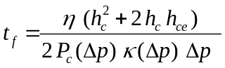 (1)

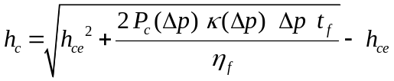 (2)
Please calculate also Δp=f(hc, tf) from (1)

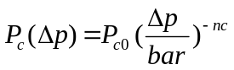 (3)

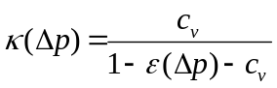 (4)

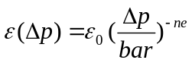 (5)

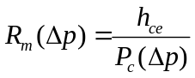 (6)

rc(Δp)=1/Pc(Δp) (7)

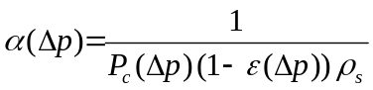 (8)
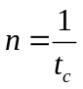 (9)
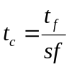 (10)

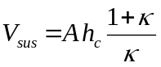 (11)
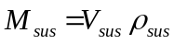 (12)

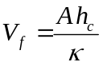 (13)
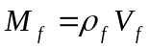 (14)

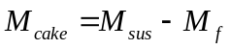 (15)
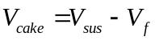 (16)

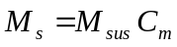 (17)
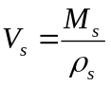 (18)

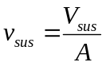 (19)
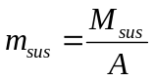 (20)

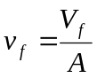 (21)
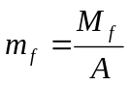 (22)

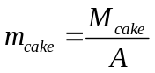 (23)
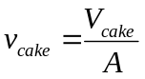 (24)

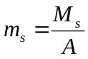 (25)
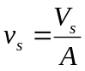 (26)

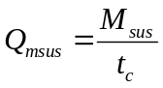 (27)
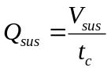 (28)

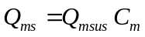 (29)
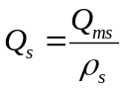 (30)

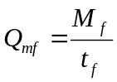 (31)
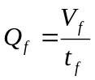 (32)

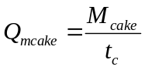 (33)
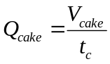 (34)

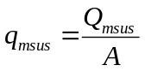 (35)
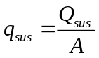 (36)

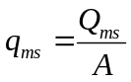 (37)
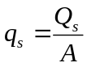 (38)

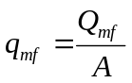 (39)
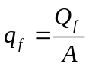 (40)

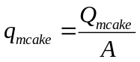 (41)
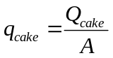 (42)

To the Calculation Part

First question is which parameters we want to have as input/output?

Above the Simulations table we have two blocks of material data:
The first block enables the input of the following parameters:

ηf (mili Pa s) (i)

ρf (kg/m3) (i/o)
ρs (kg/m3) (i/o)
ρsus (kg/m3) (i/o)

Cm (%) (i/o)
Cv (%) (i/o)
C (g/l) (i/o)

The second Block enables the input of the cake porosity or kappa ε/κ, the cake permeability Pc/rc/a and the filter medium resistance hce/Rm.

Actually the input of cake porosity or kappa ε/κ and the cake permeability Pc/rc/a is indirect.

The cake porosity ε and the parameter κ

What we input for the cake porosity ε is ε0 and the coefficient ne. From these 2 parameters the cake porosity e is calculated using the following equation:

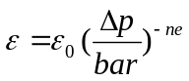 (a1)

For the calculation of κ0/ κ from ε0/ ε and the suspension solids concentration Cv we use the following equation:

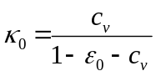 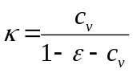 (a2)

The calculation of ε/κ is related to a definite simulation for which a definite Δp is entered or calculated. As soon as the Dp for the simulation is known (input/calculated) then the parameters ε/κ can be calculated and displayed as columns in the simulation table!

Any changes in ε0/ κ0 or ne can be valid for only the active simulation or for the active Series or the active Suspension or even the active Project!

The cake Permeability Pc/rc/a and the cake compressibility nc

The order of the Parameters Pc/rc/a should be changeable because different companies/countries prefer to work with different parameters. For example in England they work with a and in Germany with Pc or rc.

What we actually enter is one of the parameters Pc0/rc0/a0 and also the cake compressibility nc and from these parameters we calculate using the following equations Pc/rc/a. The parameters Pc/rc/a are then displayed as separate columns in the Simulation table. Please notice that these parameters (Pc/rc/a) can only be calculated if the pressure difference for the active simulation is known (see eq. below):

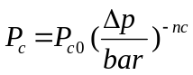 (a3)

rc=1/Pc (a4)

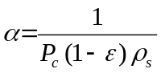 (a5)

Any changes in Pc0/rc0/a0 or nc can be valid for only the active simulation or for the active Series or the active Suspension or even the active Project!

The Filter medium resistance hce and Rm0

We should enter one of these parameters (hce or Rm0) and the other should be calculated using the following equation:

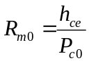 (a6)

Any changes in hce/Rm0 can be valid for only the active simulation or for the active Series or the active Suspension or even the active Project!

!!! We should enable that the ε/κ,or/and Pc/rc/a or/and hce can be entered in the table. That means we have 2 options for the above 3 parameter –groups:

- The parameters ε/κ,or/and Pc/rc/a or/and hce are calculated in the fields above the SImtable and displayed in the columns of the sim table.
- The parameters ε/κ,or/and Pc/rc/a or/and hce can be changed in the table, so that any values can be assigned to them!

In this case we need below of each of these 3 parameter groups to have a checkbox “Input value in the Table”. If this checkbox below this group is checked that means we can enter any value of these parameters. By unchecking the Checkbox the calculated value according the above equations is taken and displayed!

Which Parameters we will have Input/Output

A | Dp | sf | n | tc | tf | hc | Mf | Msus | Vsus | Ms | Qsus | Qmsus | Qms
m2 | bar | % | min-1 | s | s | mm | kg | kg | l | kg | l/h | Kg/h | kg/h

We will have the above 14 parameters which can be input or output and all other parameters should be only calculated!

For the above 14 parameters we have parameter groups:

- A
- Dp
- sf, n, tc, tf
- hc, Mf, Msus, Vsus, Ms
- Qsus, Qmsus, Qms

Important:
If we enter one of the parameters: Mf, Msus, Vsus, Ms then the area A has to be input. That means we shouldn’t calculate the area A from these parameters. The area A should be calculated only in case of entering one of the parameters Qsus, Qmsus, Qms (see the Design Option below).

We will have 3 Calculation Main Options

- Standard Calculation
- Design
- Optimization

To 1) In Standard Calculation the area A is given but not the parameter group: Qsus, Qmsus, Qms
To 2) The Parameter group Qsus, Qmsus, Qms is given and the filter Area is calculated
To 3) The Parameter group Qsus, Qmsus, Qms AND the filter area are given

The User has to be able for each simulation to select which option he wants to have. This could be done by having 3 option buttons.

1)Standard Calculation

In this case we have always the area A as input and the Qms (when I write Qms I mean the whole group (Qsus, Qmsus, Qms)).

We have for this main option 3 suboptions:

- Dp input – hc calculated
- Hc input – Dp calculated (when we write hc we mean one of the parameters of the hc-group)
- Dp and hc input

- Dp input – hc calculated
When selecting this option we have besides Dp the following 2 parameters as input:

- sf, (n/tc)
- sf, tf
- (n/tc), tf

- Hc input – Dp calculated
When selecting this option we have besides hc the following 2 parameters as input:
- sf, (n/tc)
- sf, tf
- (n/tc), tf

- Dp and hc input
When selecting this option we have besides Dp and hc the following parameter as input:
- sf
- (n/tc)
- tf

That means for the Standard Calculation we have 9 possibilities regarding the input parameters.

- Design

In this case we have always the Qms as input and the filter area A is calculated (when we write Qms we mean the whole group (Qsus, Qmsus, Qms))

We have for this main option 3 suboptions:

- Dp, hc, n/tc as input
- Dp, hc, sf as input
- sf, n/tc, hc as input

That means for the Design Option we have 3 possibilities (options).

- Optimization

In this case we have always the filter area A and the Qms as input (when we write Qms we mean the whole group (Qsus, Qmsus, Qms))

We have for this main option 3 suboptions:

- Dp, sf as input
- hc, sf as input
- n/tc, sf as input

That means for the Optimization Option we have 3 possibilities (options).
Ideas and necessary equations

We should have maybe a moveable window, where we can do for each active simulation our selection, that means which option we want to have. After selecting the option another movable window should appear that enables the input of our parameters showing also the min-max values!!! Automatically when entering the data in this small window these data will also appear in the simulations table. All input data should appear in blue colour and the calculated values in black.

Very important concept is the display of the min-max values of the input parameters so that the user can enter only meaningful data. These min-max values should be taken or calculated using the Retsrictions-values. These restriction values should be one label of the Settings window.

Which parameters should be included in the restrictions settings?

A Amin-Amax
Dp Dpmin-Dpmax
Sf sfmin-sfmax
n/tc nmin-nmax / tcmin-tcmax
hc hcmin-hcmax

For each machine type we should have individual default restrictions, which of course we can change!

1) Standard Calculation - To the Algorithms and equations

Dp input – hc calculated

When selecting this option we have besides Dp the following 2 parameters as input:

- sf, (n/tc)
- sf, tf
- (n/tc), tf

To 1) As input we have

A, Δp, sf, n/tc

(if n is input automatically tc is calculated because tc=1/n)

What parameters from the 14 which are listed as i/o parameters have to be calculated?

tf | hc | Mf | Msus | Vsus | Ms | Qsus | Qmsus | Qms

Calculation of tf
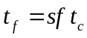 (b1)

Calculation of hc

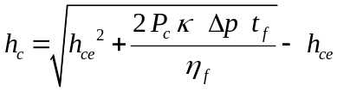 (b2)

hce is input or calculated from Rm0 and Pc0 (see eq. (a6))
Pc is calculated from eq.(a3) using the entered Δp
κ is calculated from eq.(a2) using e that is calculated from eq. (a1)
Δp is input
tf is calculated from eq. (b1)
ηf is input

Calculation of Mf

(b3)
(b4)

Calculation of Msus and Vsus

(b5)
(b6)

Calculation of Ms

(b7)

Calculation of Qsus, Qmsus, Qms

(b8)
(b9)
(b10)

To 2) A, Dp, sf, tf is input
Calculation of n/tc, (hc-group, Qms-group)

The input of A, Dp and sf is no problem because we have the min-max values from the restrictions. But what about the tf-value? We should first calculate min-max values and these values depend on the order we input the parameters. For example if we enter the tf first then in this case we calculate tfmin-tfmax as follows:

We have tfmin from the hcmin and Dpmax and we calculate tfmax from hcmax and Dpmin (see following eq.)

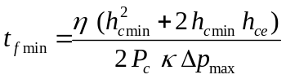 (b11)

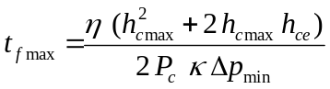 (b12)

On the other hand we have sfmin- sfmax and tcmin and tcmax
From the above restrictions we also have tfmin and tfmax

tfmin = tcmin sfmin (b13)
tfmax= tcmax sfmax (b14)

The tfmin has to be the bigger number of (b11) and (b13)
The tfmax has to be the smaller number of (b12) and (b14)

What is now if I enter first the Dp? Automatically with eq. (b11) and (b12) new tfmin and tfmax is calculated and automatically new boarders for tfmin and tfmax.

What now if the sf is also entered? In this case we have a recalculation of the borders in (b13) and (b14) and again we recalculate the borders of tf (tfmin – tfmax).

Then we enter tf and all other parameters are calculated using the following equations:

tc= tf/sf (b15)

n=1/tc (b16)

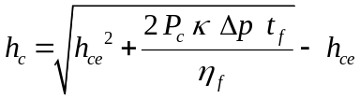 (b17)

To 3) A, Dp, (n/tc), tf are input
Calculated are sf, hc-group, Qms-group

Before entering any data we have for tf min-max values which are calculated from (b11) until (b14). After entering Dp a recalculation of tfmin-tfmax is done. Having also tc we have again a recalculation of tfmin-tfmax.

Entering now tf we have automatically sf!
sf=tf/tc (c1)

Having tf and Dp we have automatically hc (see eq. (b17))

Hc input – Dp calculated
When selecting this option we have besides hc the following 2 parameters as input:
- sf, (n/tc)
- sf, tf
- (n/tc), tf

To 4)

Input: A, sf, (n/tc), hc

How the calculation is done?
Having sf and (n/tc) we automatically get the filtration time tf:

tf= sf tc (c2)

Having now the tf and entering the cake height hc we calculate the pressure difference Δp. This calculation should be done by using the following eq:

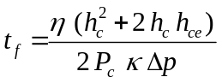 (c3)

and with
(c4)
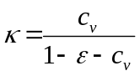 (c5)
(c6)

We get the equation which enables the calculation of the pressure difference Δp via Newton method for example.
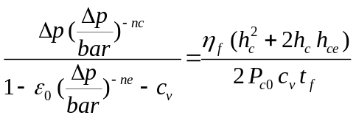 (c7)

As already said the data of the above parameters (A, sf, n/tc, hc) have to be entered in a separate small table where we can also see the min-max values for each parameter. These min-max values should be always recalculated as soon as we enter one parameter.

Lets examine the min-max values of the input parameters for this option:

Filter Area A (m2) | Amin |  | Amax
filtration area fraction sf(%) | sfmin |  | sfmax
Cycle Time tc (s) | tcmin |  | tcmax
Cake height hc (mm) | hcmin |  | hcmax

Having an sfmin and sfmax with tcmin and tcmax we have automatically tfmin and tfmax:

tfmin= sfmin tcmin
tfmax = sfmax tcmax

As we know we have also Dpmin and Dpmax in our Restrictions window.

With tfmin and Dpmin we can calculate a hcmin usind the following equation:

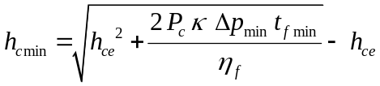

With tfmax and Dpmax we can calculate a maximal possible cake height hcmax

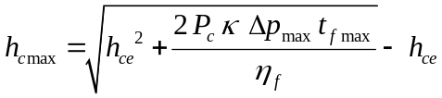

That means we have 2 pairs of (hcmin-hcmax) values. The one pair is what we have entered in our restrictions window and the other pair is what we calculate using the above equations. Thats why we have to compare these 2 pairs and then take as hcmin the maximal hcmin of the two pairs and hcmax the minimal hcmax of the two pairs.

An example: We enter in restrictions hcmin= 3 mm and hcmax= 100 mm (for identifying the restriction values we should add “r” as index. For example:

hcmin,r= 3 mm
hcmax,r=100 mm

Having sfmin and sfmax and tcmin and tcmax as we showed above we can calculate hcmin and hcmax using the above equations. For example we get:

hcmin= 2 mm
hcmax = 76 mm

The hcmin and hcmax values which should be displayed are:
hcmin= hcmin,r= 3 mm (restrictions value because higher than the hcmin calculated value)
hcmax=hcmax,cal = 76 mm (for hcmax the calculated value is taken because the smallest).
Imagine we do not consider this and we display as hcmax not 76 mm but the restrictions value (hc=100 mm) and we go and enter this maximal value. Even in the case that we enter then the maximal sf and the maximal tf we will get as result a Dp value which is higher than the restrictions value and this is not allowed!

Now imagine we enter the sf-value. With the tcmin,r and tcmax,r values we have new tfmin and tfmax values and together with Dpmin and Dpmax we have new calculated values for hcmin-hcmax. Again we have to compare these values with the restriction values and display the maximal hcmin and the minimal hcmax as the new border values.

Imagine now we enter as next the tc-value then in this case we have a definite tf-value because
tf= sf tc

with this tf value and the Dpmin and Dpmax we calculate new borders for the cake height hcmin and hcmax. Now we can enter the hc-value and we are sure that this value is a possible value!

What happens if after entering the sf-value we want to enter the cake height first and as last the tc-value? In this case after entering the cake height hc and having the Dpmin and Dpmax values from the restrictions we can calculate tfmin and tfmax values. Having tfmin and tfmax we calculate new tcmin and tcmax and we compare them with the tcmin,r and tcmax,r.

What happens for example if we enter first the cake height hc? In this case having the Dpmin and Dpmax we calculate tfmin and tfmax and with sfmin and sfmax new tcmin and tcmax. But actually this way is not correct. Why we should calculate new tcmin and tcmax and not sfmin and sfmax?

The solution is the following: The new calculation of the borders should be done after we click in the parameter field. That means imagine that we first enter the cake height hc and then we want to enter the sf-value. In this case we click in the sf-field and automatically new calculation of the sfmin-sfmax is done and not of the tcmin-tcmax!!!

What for example if we enter sf after hc? How we calculate the new sfmin-max borders? Having hc and Dpmin, Dpmax we get tfmin and tfmax. With the tcmin,r and tcmax,r we calculate sfmin and sfmax and we compare these values with the restriction values, so that the maximal sfmin and the minimal sfmax are taken as the new borders.

The Question is now
What should happen if I want to change one value. For example I have already entered the cake height hc then the sf-value and then the tc-value. In this case we should click in the parameter field which we want to change and deleting the parameter new borders with the other 2 parameters are calculated!

To 5)
Input A, hc, sf, tf

Having hc and tf we have the Dp-value (see eq. c7). The tc-value is easily calculated:

tc=tf/sf

To 6)
Input A, hc, (n/tc), tf

Having hc and tf we calculate Dp. Having tc and tf we calculate sf.

Dp and hc input

When selecting this option we have besides Dp and hc the following parameter as input:
- sf
- (n/tc)
- tf

Case 7) Input: A, Dp, hc, sf

Having Dp and hc we have tf. Having tf and sf we have tc/n.

Case 8) Input A, Dp, hc, n/tc
Having Dp and hc we have tf. Having tf and tc we have sf.

Case 9) Input A, Dp, hc, tf
This case is not possible because having Dp and hc we have automatically tf!!!

Equations for the Calculation of the 14 i/o parameters

A | Dp | sf | n | tc | tf | hc | Mf | Msus | Vsus | Ms | Qsus | Qmsus | Qms
m2 | bar | % | min-1 | s | s | mm | kg | kg | l | kg | l/h | Kg/h | kg/h

Calculation of tf from hc and Dp

(1)

Calculation of hc from Dp and tf

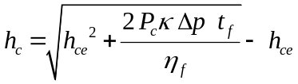 (2)

Calculation of Pc

(3)
Calculation of κ
(4)
(5)

Calculation of Dp from tf and hc
(6)

Calculation of tf from tc and sf

(7)
Calculation of n from tc
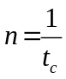 (8)
Calculation of Mf from hc
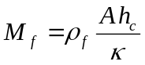 (9)

Calculation of Msus, Vsus, Ms from hc
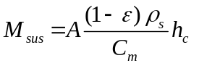 (10)
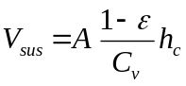 (11)
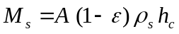 (12)

Calculation of Qsus,.Qmsus, Qms from A, hc and n
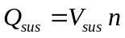 = 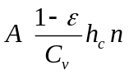 (13)
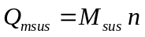=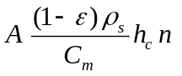 (14)
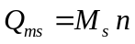 = 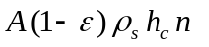 (15)
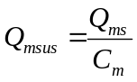 (16)
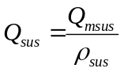 (17)
Option: Standard Calculation (Input of filter area A)
A) Dp input – hc calculated

- A, Dp, sf, n/tc
- A, Dp, sf, tf
- A, Dp, n/tc, tf

To 1) A, Δp, sf, n/tc

(if n is input automatically tc is calculated because tc=1/n (see eq. (8))

Calculation of tf
By using eq. (7)

Calculation of hc
After calculation of tf using eq. (7) the cake height hc is calculated using eq. (2)

Calculation of Mf
After the hc is calculated Mf is calculated by using eq. (9)

Calculation of Msus, Vsus, Ms
Use eq. (10), (11), (12)

Calculation of Qsus, Qmsus, Qms
Use eq. (13), (14), (15)

To 2) A, Δp, sf, tf
Calculation of n/tc
by using eq. (7)
Calculation of hc
hc is calculated using eq. (2) with the entered Dp and tf
all other like option 1)

To 3) A, Δp, tc, tf
Calculation of sf
by using eq. (7)
all other calculations like option 1)

B) Hc Input and DP calculated
4) A, sf, n/tc, hc
5) A, sf, tf, hc
6) A, n/tc, tf, hc

4) A, sf, n/tc, hc
Calculation of tf from sf and tc
Using eq. (7)
Calculation of Dp from tf and hc
Using eq. (6)
All other parameters are calculated like in the other options

5) A, sf, tf, hc
Calculation of tc from sf and tf
Using eq. (7)
Calculation of Dp from tf and hc
Using eq. (6)
All other parameters are calculated like in the other options
6) A, n/tc, tf, hc

Calculation of sf from tc and tf
Using eq. (7)
Calculation of Dp from tf and hc
Using eq. (6)
All other parameters are calculated like in the other options

C) DP and hc Input
- A, Dp, hc, sf
8) A, Dp, hc, n/tc

7) A, Dp, hc, sf

Calculation of tf from Dp and hc
By using eq. (1)

Calculation of tc
After having tf by using eq. (7)
All other parameters are calculated like in the other options

8) A, Dp, hc, n/tc

Calculation of tf from Dp and hc
By using eq. (1)
Calculation of sf
After having tf by using eq. (7)
All other parameters are calculated like in the other options
Option: Design (Input of Qms-Group)
9) Input Qms, Dp, hc, n
Calculation of filter area A
By using eq. (15)
Calculation of tf
Using eq. (1)
Calculation of sf
Having tf and n=1/tc by using eq. (7)
Calculation of Mf, Msus, Vsus, Ms
By using eq. (9), (10), (11), (12)
Calculation of Qmsus and Qsus from Qms
By using eq. (16) and (17)

10) Input Qms, Dp, hc, sf
Calculation of tf from Dp and hc
Using eq. (1)
Calculation of tc/n from tf and sf
Having tf from eq.(1) and sf using eq. (7) we get n/tc
Calculation of area A
After having n (see above) using eq. (15) the filter area A is calculated
Calculation of Mf, Msus, Vsus, Ms
By using eq. (9), (10), (11), (12)
Calculation of Qmsus and Qsus from Qms
By using eq. (16) and (17)

11) ) Input Qms, sf, n, hc
Calculation of area A
By using eq. (15)
Calculation of tf
By using eq. (7)
Calculation of Dp
Having tf and hc by using eq. (6)
Calculation of Mf, Msus, Vsus, Ms
By using eq. (9), (10), (11), (12)
Calculation of Qmsus and Qsus from Qms
By using eq. (16) and (17)
Option Optimization
- Dp, sf as input
- hc, sf as input
- n/tc, sf as input

12) Input A, Qms, Dp, sf
Calculation of n, tf, hc
Qms=
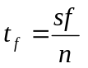
We have 3 equations and 3 unknown parameters which give us n, tf, hc
Calculation of Mf, Msus, Vsus, Ms
By using eq. (9), (10), (11), (12)
Calculation of Qmsus and Qsus from Qms
By using eq. (16) and (17)

13) A, Qms, hc,sf
Calcualtion of n
Using eq. (15)
Calculation of tf
After having n/tc with sf as input by using eq. (7)
Calculation of Dp
Having hc and tf by using eq. (6)
Calculation of Mf, Msus, Vsus, Ms
By using eq. (9), (10), (11), (12)
Calculation of Qmsus and Qsus from Qms
By using eq. (16) and (17)

14) A, Qms, n/tc, sf
Calcualtion of the cake height hc
By using eq. (15)
Calculation of tf
Having n/tc and sf by using eq. (7)
Calculation of Dp
Having hc and tf by using eq. (6)

Calculation of Mf, Msus, Vsus, Ms
By using eq. (9), (10), (11), (12)
Calculation of Qmsus and Qsus from Qms
By using eq. (16) and (17)

